N95 Mask Fit testing Process

- IPAC Team will send the Pre-screening sheet to the requesting organization for the staff to complete and bring with them on the day of testing.

- Contact person or Lead at the requesting site will complete the booking sheet template- individuals will be booked in 15- minute time slots. Our mask fit test can conduct up to 28- 30 individuals in a 8 hour day.

- During the N95 mask fit testing session the individual will be:
  - Mask fit tested
  - Educated on don/doff of the N95 masks

- Staff will need to be actively COVID-19 pre-screened prior to their mask fit test-As discussed if Sick could provide a pre-screener that would be appreciated.

- Staff will only be tested on the Kimberley-Clark Halyard Fluid shield 3 N95 Particulate Filter Respirator and will be given a the mask to keep that they are tested on.
  - 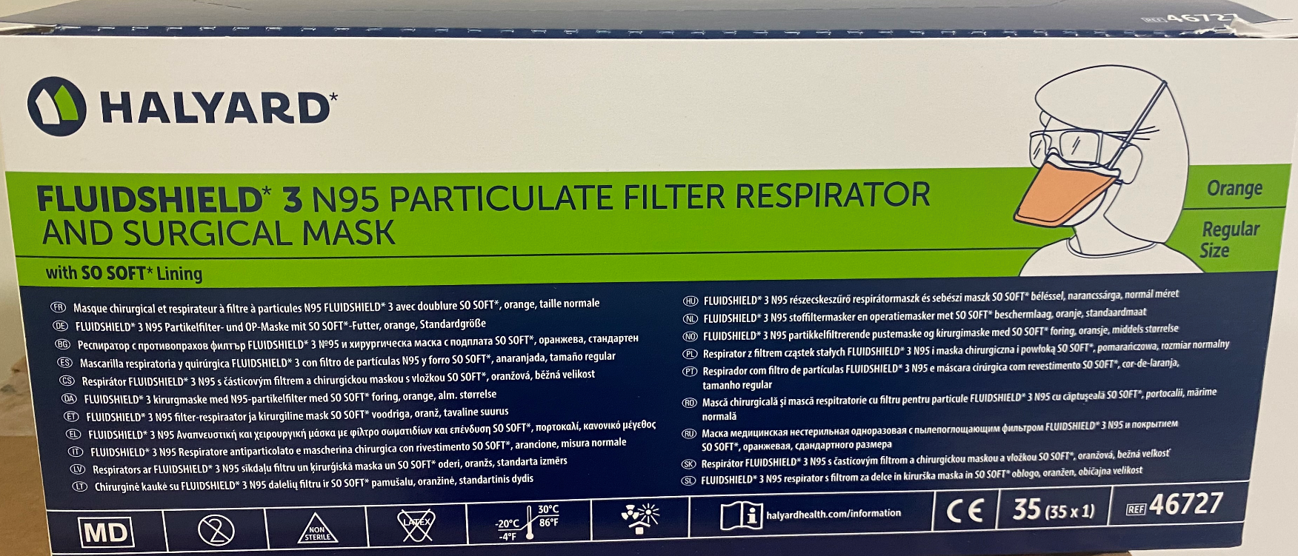

- Staff will be requested to be bring a paper bag to place the N95 mask in after if it used for testing.

Thank you
The Safehaven IPAC Team

